
Objectives
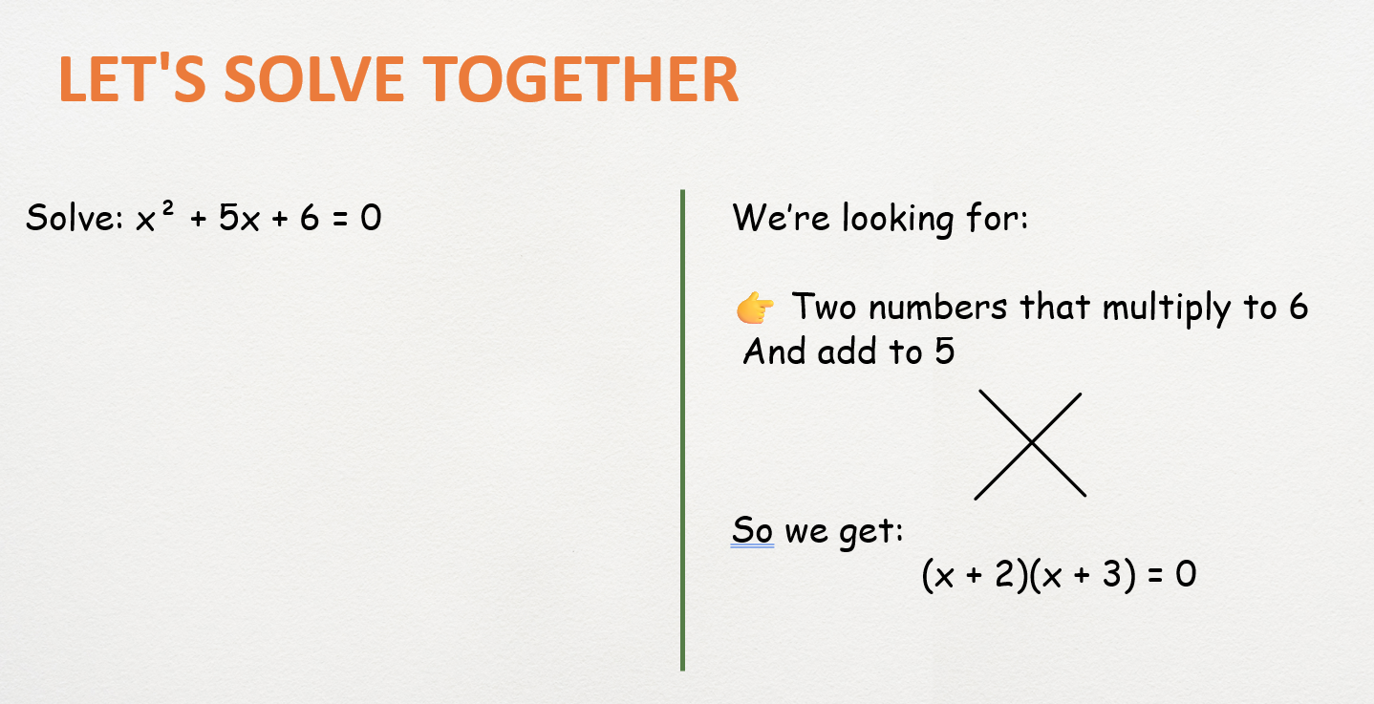
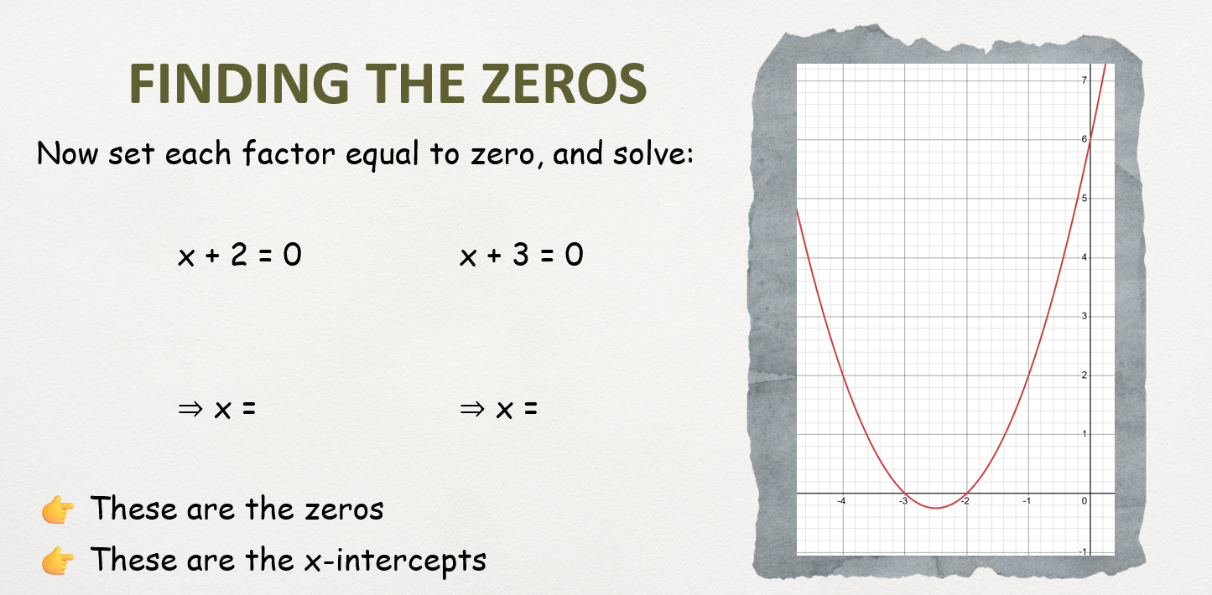
“First, I found two numbers that multiply to ___ and add to ___. Next, I wrote the factored form… Then, I set each factor equal to zero. Finally, the zeros are ___ and ___. These are the x-intercepts of the parabola.”
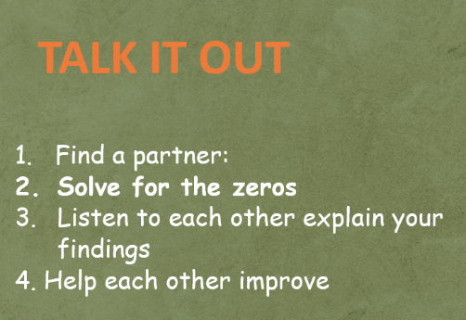
Partner's name:

Copy your Quadratic equation:

Solve:

Explain:
___________________________________________________________________________

___________________________________________________________________________

